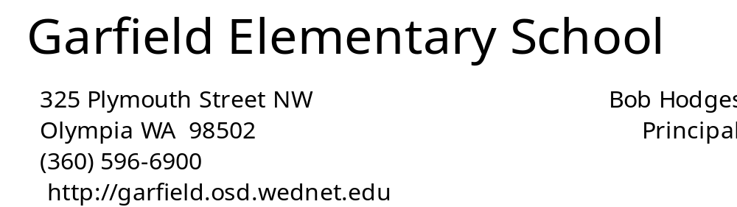

__________________________________________________________________________________________
April 25, 2014
JJjkjlkjlk
May Calendar of Events

April 29 4th Grade MSP Writing
April 30 5th Grade MSP Reading
May 1 3rd Grade MSP Reading
May 2 4th Grade MSP Writing
May 5 6:30 PTA Meeting
May 6 5th Grade MSP Math
May 6 5:00 Site Council Meeting
May 7 9:40 Late Start
May 8 3rd Grade MSP Math
May 8 6:00 Next Year Kindergarten Parent Night
May 9 4th Grade MSP Reading
May 13 4th Grade MSP Math
May 14-16 5th Grade Outdoor School
May 16 6:30 PTA Movie Night
May 23 12:45 Ms.Wheelchair America Visits
May 26 No School – Memorial Day
May 28 12:45 Garfield Kids Variety Show
Shop Talk - Close Reading

In her article, What Students Can Do When the Reading Gets Rough, Sunday Cummins addresses a new focus on the practice of “close reading” of challenging informational and narrative text that is driven by the Common Core. In the past, when students, particularly those in the middle grades, were asked to read, they would scan through the text. They were reading the words, but were they actually absorbing the multi-leveled meanings of what they read? Students were rarely asked to think deeply about the text nor were they asked to do anything with what they learned.
With the implementation of new Common Core Standards, students are asked to engage in deeper reading and thinking. Close reading is a systematic analysis of a text for a particular purpose. Students analyze text not only on the paragraph level, but they also look closely at smaller segments. They answer text dependent questions and analyze the author’s choice of words and phrases. Students are also asked to support their interpretations of text with evidence. When identifying the main idea of a story, or the authors’ intent, students must use text-based evidence to support their ideas.
The point of close reading is to teach students to independently examine text and then use that text for its main purpose: to enhance the reader’s knowledge and ideas. When teachers provide students with the time, instruction and support they need to learn close reading, they provide them with an invaluable long-term academic skill.

Jane Al-Tamimi
Garfield Site Council

J
PP
b

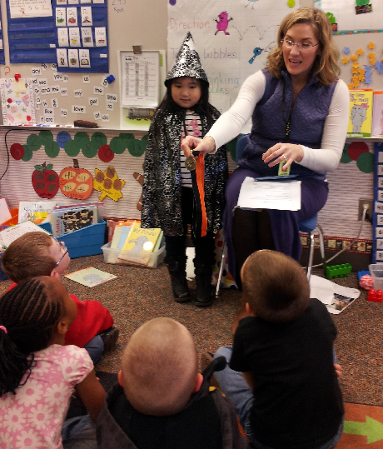
Michelle, in Mrs. Olsen’s class, has read
100 pouch books! They celebrate with the
wizard ceremony.

Arrival/Dismissal Information for Special Days

One Hour Late Start Days for Improving
Teaching and Learning
9:40 Start
May 7, and June 4

No School Days
May 26 - Memorial Day

Last Day
June 12 - 11:45 Dismissal

Student Learning Behavior Targets in Garfield Classrooms –
Section 4 - Common Expectations and Language

1. BE AN ACTIVE LISTENER
What student looks like –
a) voice off
b) hands empty
c) eyes on speaker
d) attentive body language
How adults support –
a) wait for compliance before beginning presentation
b) teach, model and practice
c) use natural consequences to reinforce

kk

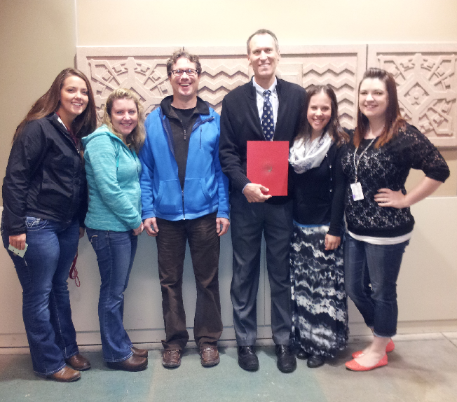
Mr. Hodges recently received the 2014 Distinguished Educator Award from St. Martins University. He is pictured here with some of the best teachers in the state: Mrs. Saunders SMU '12, Mrs. Koster SMU '04, Mr. Dodge SMU '98, Ms. Meadows SMU '12, and Mrs. Duncan SMU '12.


Olivia, Deirdre, and Emilee, three of
Mrs. Mock’s Hair Club Stars!

OSD HI-CAP PROGRAM & SERVICES
MEETING FOR PARENTS OF ELEMENTARY STUDENTS
WHO:
Parents of students currently participating in the PATS pull-out program in grades 2, 3, & 4
AND parents of all other students currently enrolled in Kindergarten through 4th grade.

WHEN:
May 8, 2014, 6:30-7:30 pm in the Knox Building Boardroom
1113 Legion Way SE, Olympia 98501

WHAT:
An orientation regarding the Olympia School District's Highly Capable (aka gifted; PATS) 2014-15 service plan. Topics will include the student nomination/screening/selection procedure, elementary grade level service options, and a review of the revisions to the state regulations regarding highly capable students.

Questions?
Please email Jen Flo at jflo@osd.wednet.edu

Dear Oso,
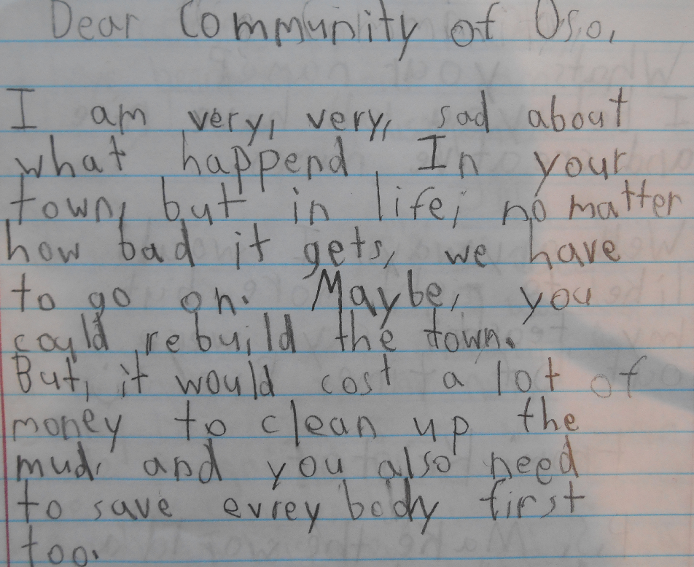
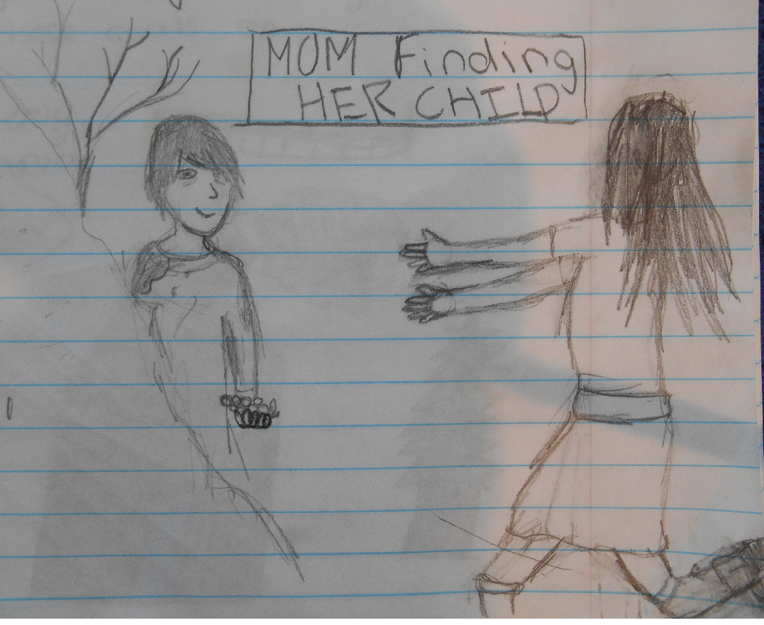

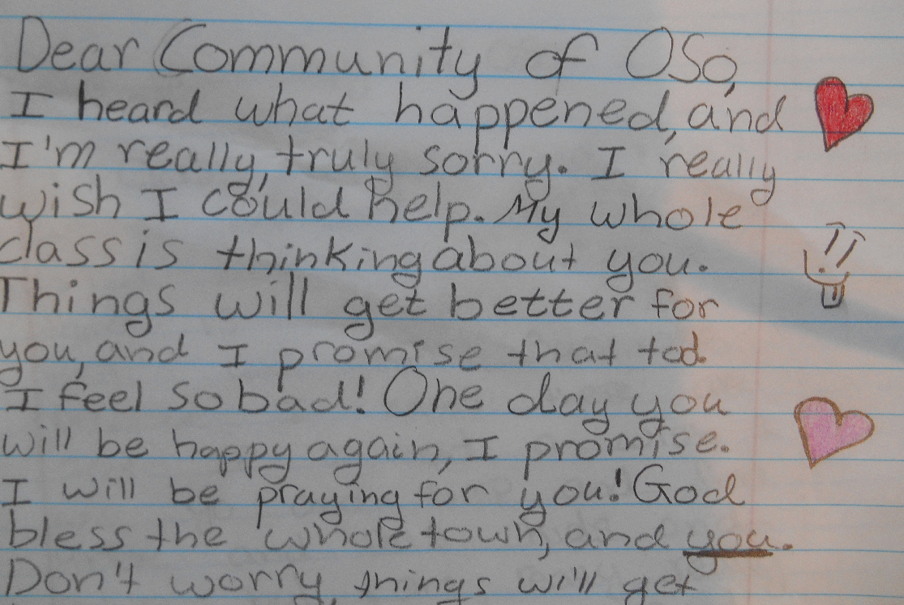
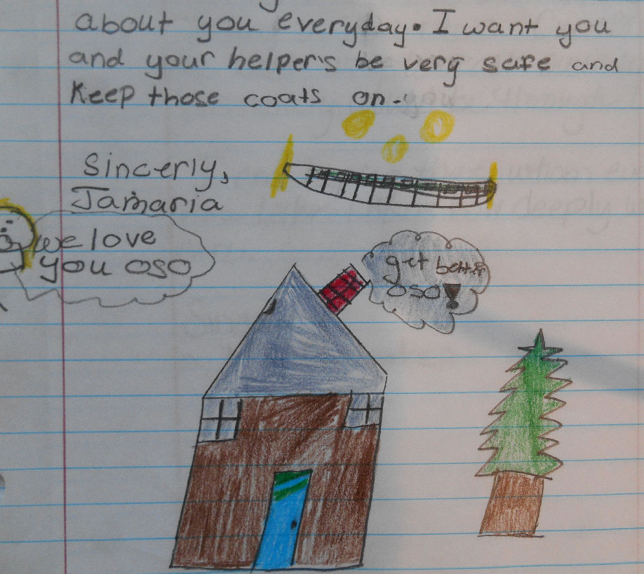

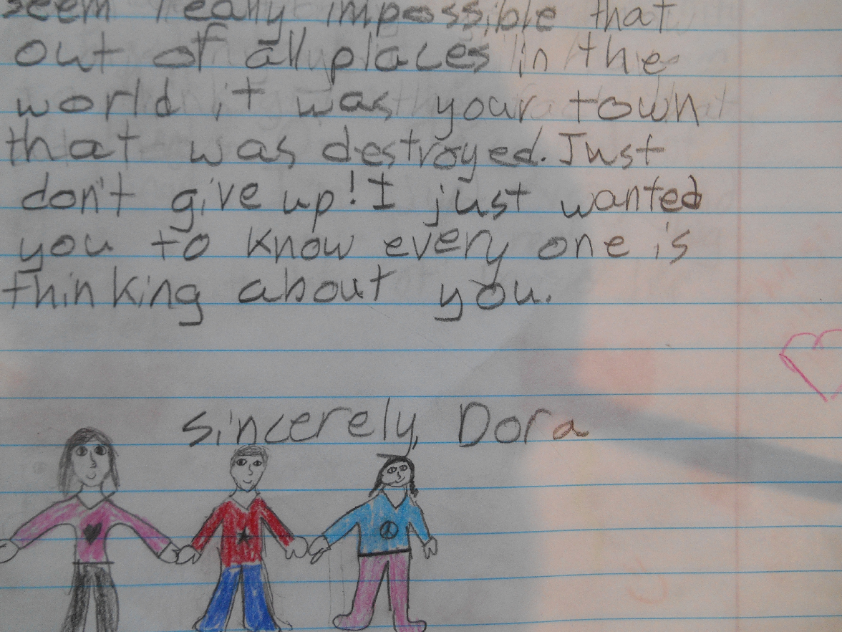

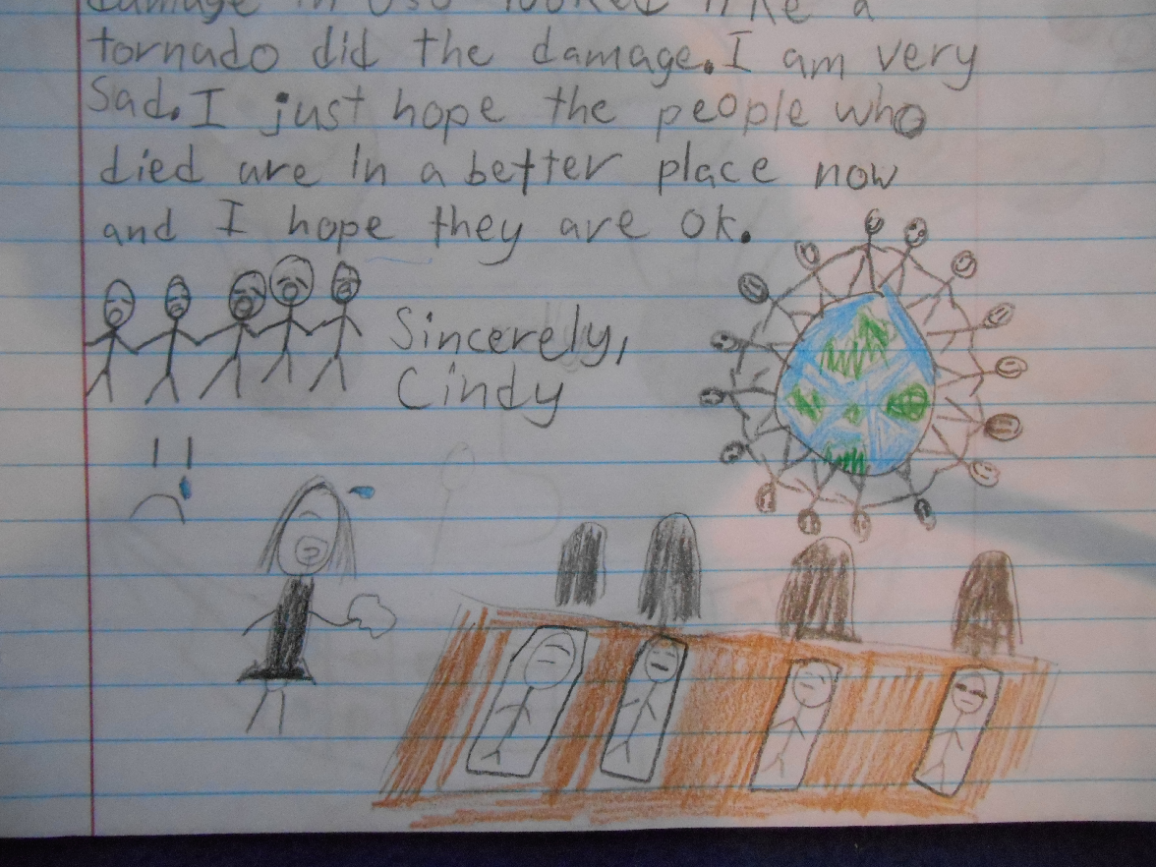

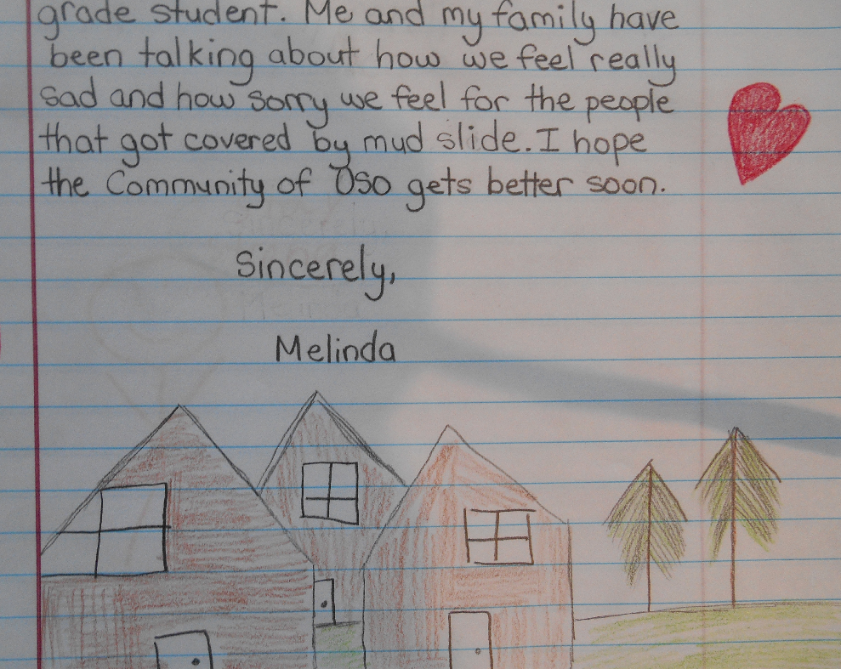

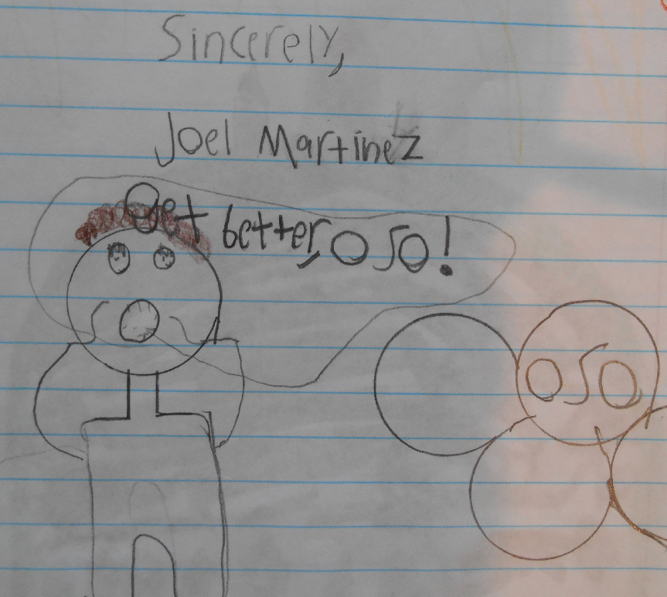

Love, Mr. Dodge’s 4th Grade Class

Books and Blankets in the Library means after hours fun for families!
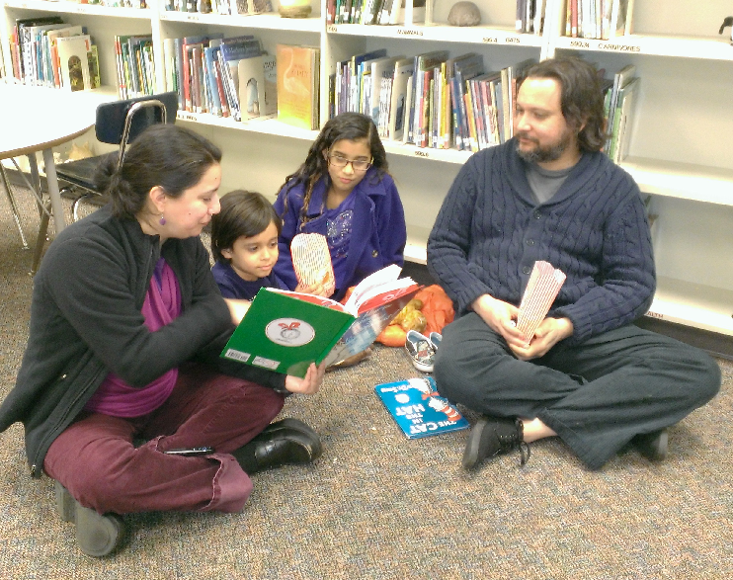

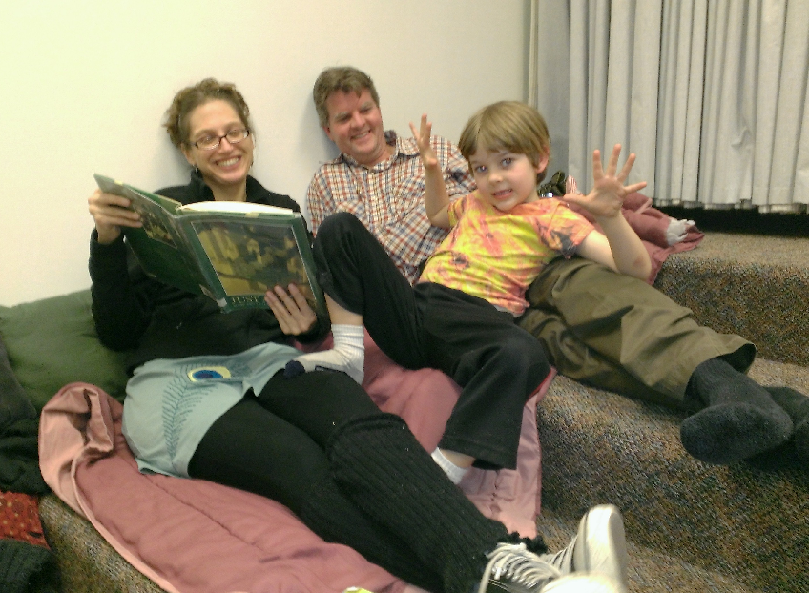

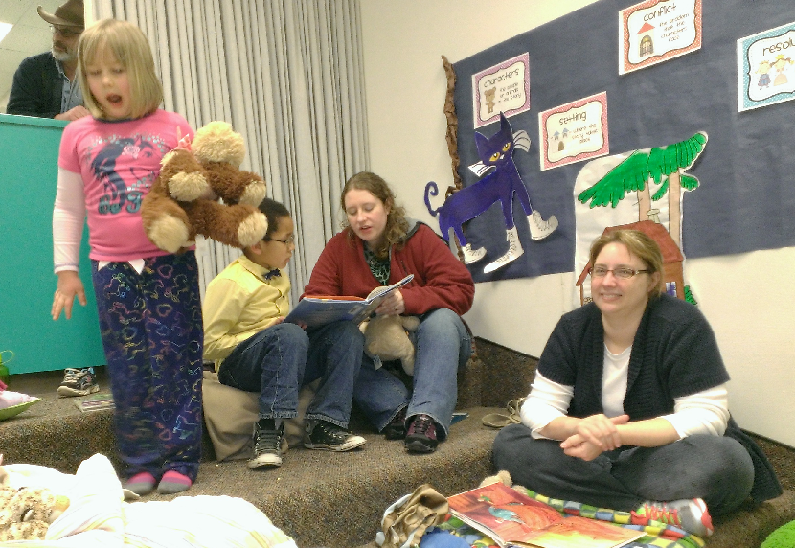
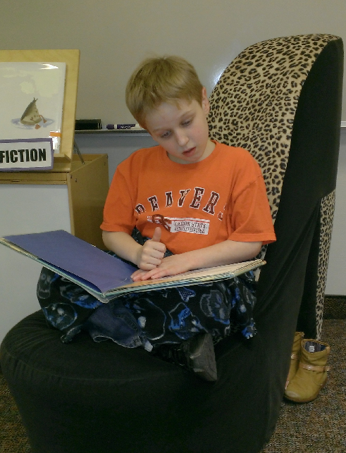

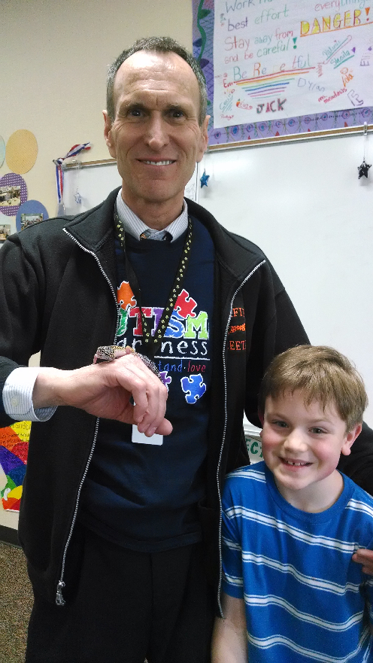
Dylan, Mr. Hodges, and Big Bob
- Dylan's gecko!

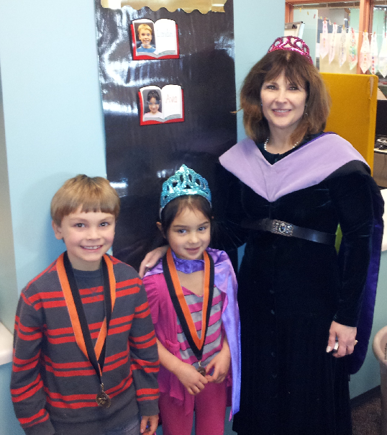
Mrs. Mock, the Pouch Book Queen, celebrates reading achievement with Landin and Ava.

