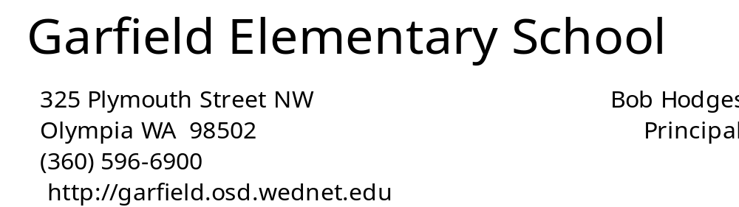

__________________________________________________________________________________________
November 1, 2013
JJjkjlkjlk
November Calendar of Events

November 1 Picture Retake Day
November 3 Daylight Savings ends-Set clocks back1 hour
November 6 9:40 Late Start
November 11 No School – Veterans Day
November 15 6:30 PTA Movie Night
November 20 9:40 Late Start
November 28 No School – Thanksgiving
November 29 No School – Thanksgiving Break
SHOP TALK

The purpose of this new section is to solicit parent, staff and community opinions, observations, ideas and commentary concerning public education.

In his article, No Child Left Alone, Bruce Kluger, a contributing columnist to the Huntington Post suggests that the increasing focus on high stakes testing, along with heavy demands at school, could be creating undue stress on our children. He asserts that students are being “dragged into adult hood” when schools focus on grades rather than on learning. Kluger is concerned that schools are no longer expecting students to ask questions, but are demanding that they have the answers already. He feels that the message that is being sent is: if kids “mess up,” they won’t have a future. That’s a lot of pressure to put on students. He sites the fact that 45 middle schools and high schools across the country have formed support networks to teach stressed-out kids relaxation techniques.
Kluger is quick to say that he is not suggesting that schools abandon high standards and hard work, he simply suggests that it should be done with the correct priority in mind - preparing kids for the academic challenges that are ahead of them.
Kluger’s concern is that when students are held to unrealistic expectations, some may not be inspired to reach higher – and some may be left without hope for the future.

J
PP
b

Garfield Wish List

Linda Zaccagnini: MORE Class Instructors
Bob Hodges: Tennis balls - used or new
Garfield Track Stars: Volunteers - mornings - 10:10-10:35
All Classrooms: PTA room reps
Playground: Large spoons (for digging in sandboxes)
Nurse: Small copier for nurse’s office.
Inexpensive, no faxing needed.

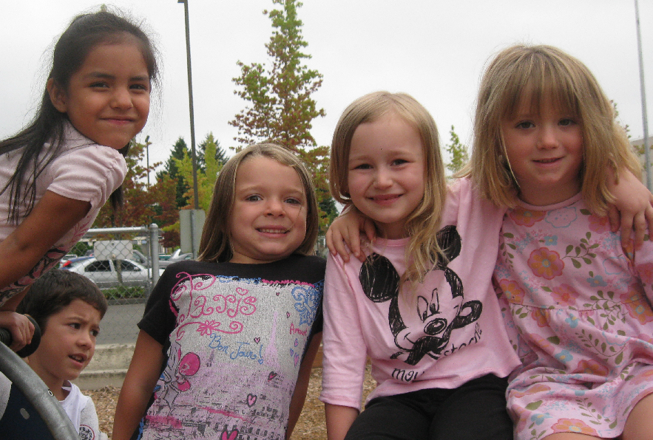
October playground pals

Snapshots from our PTA’s Wonderful World of Animals assembly (funded by cookie dough sales!)

kk
llllll

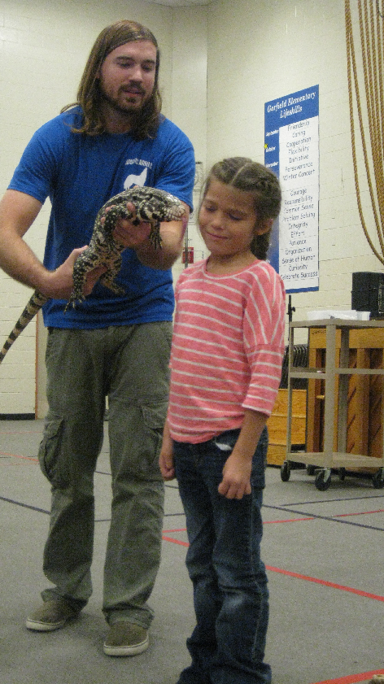

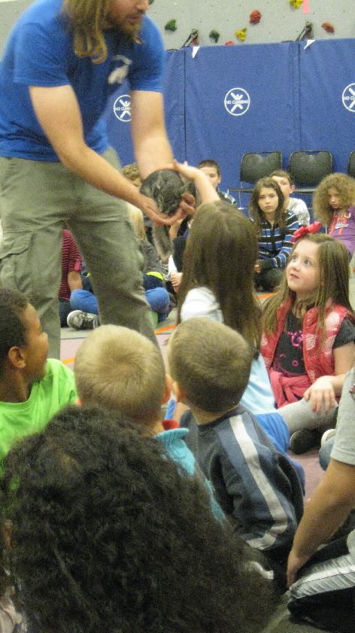

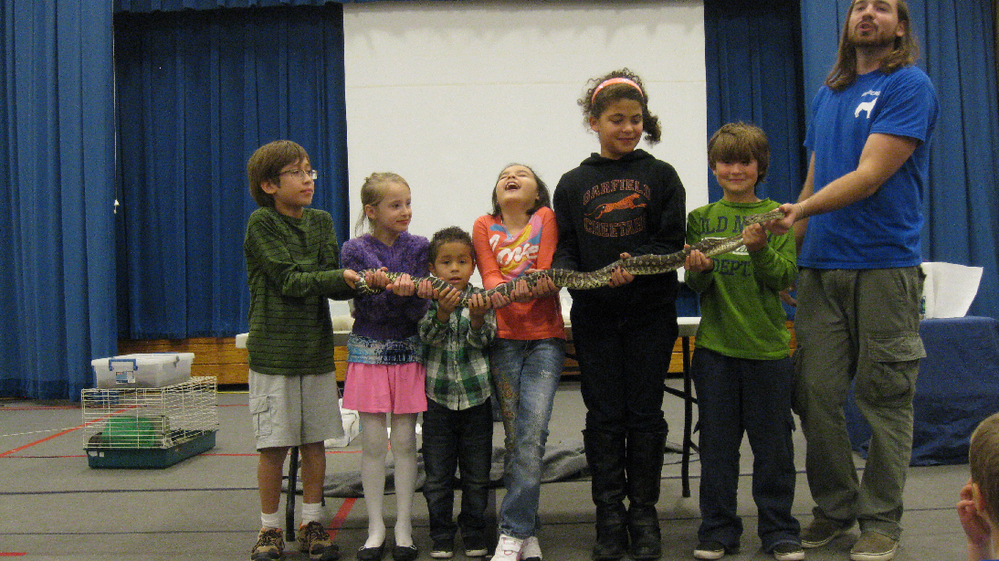

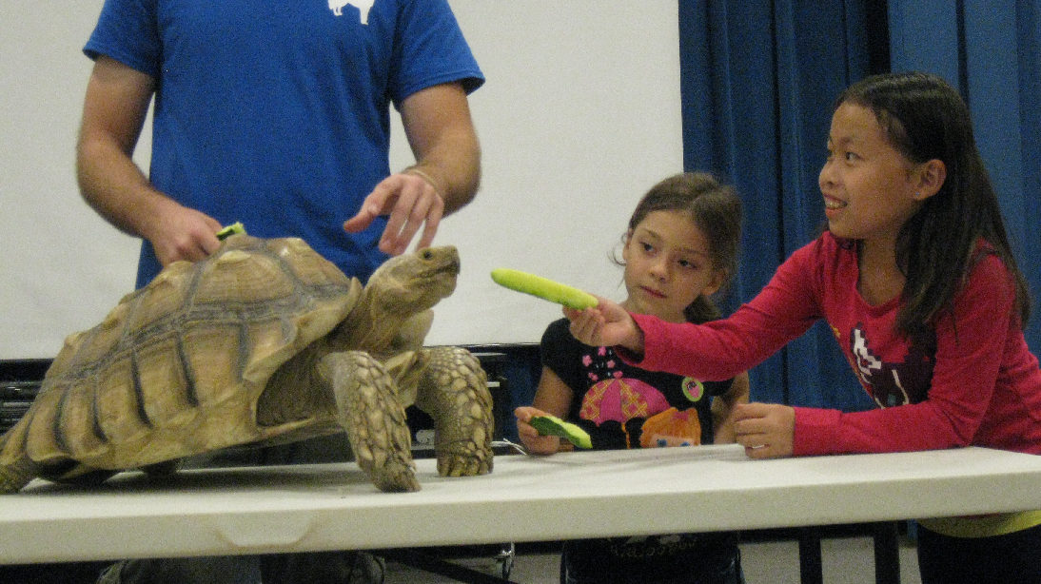

Arrival/Dismissal Information for Special Days

Half Days
Dismissal 11:45
March 7 - Teacher In-Service
March 25, 26, 27, 28

Early Release Days
Dismissal 12:32
December 6
March 14

One Hour Late Start Days for Improving Teaching
and Learning
9:40 Start
November 6, November 20, December 4,
January 8, January 29, February 5, February 26,
March 5, April 2, May 7, and June 4

No School Days
November 11 - Veterans Day
November 28-29 - Thanksgiving Break
December 2 - January 3 - Winter Break
January 20 - Martin Luther King, Jr. Day
February 17 and 18 - Presidents Day/Mid-Winter Break
April 7- 11 - Spring Break
May 26 - Memorial Day

Last Day
June 12 (unless makeup days are needed)
11:45 Dismissal

Garfield Student Behavior Management Plan
Section 2 - School-wide protocols and procedures:
- all classrooms and teaching spaces post and teach behavior expectations
- we have a school-wide incentive program for common areas
- teachers consistently reinforce behavior expectations in a positive way
- classrooms have their own behavior monitoring systems that: a) individualize; b) escalate; c) include warnings, recognition/reinforcement, and natural consequences; d) include a buddy class system; e) is utilized to the fullest extent possible before making a principal referral
- all students, staff and parents are informed that extraordinary disrespect, noncompliance, and/or physical or emotional harm will result in a principal referral and/or a communication home and may result in suspension
- more specific individualized plans may be created for some students
- Recess specific: basic recess expectations and rules will be taught; students are taught that breaking a recess rule or expectation will result in consequences – warning, problem-solving, natural consequence, brief timeout, extended timeout, referral to alternative recess activity, and/or principal referral

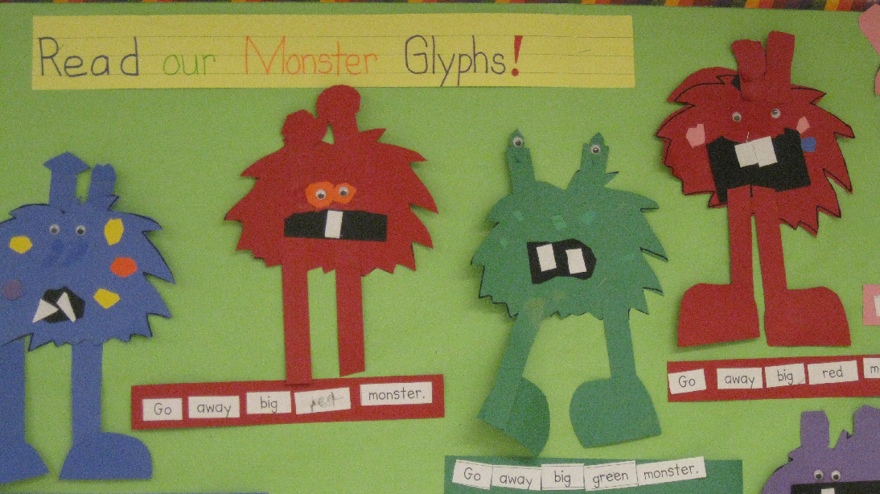
Monster Glyphs that teach us to read-
Mrs. Allen's classroom!


Jaice just hanging out.

Dear Garfield Families,

By and large, Olympia is a very safe community. However, toward the end of last school year there were a number of instances in Thurston County where students reported being confronted by strangers as they were traveling to or from school.

These situations serve as good reminders to talk with students about getting to school and home safely, regardless of whether they are walking, biking, riding the bus or riding in a car to school. We are reviewing safety tips with our students at school and hope you will reinforce that message at home as well. Here are a few things to cover with your student:
- Plan with your child what he or she should do in a dangerous situation.
- Encourage your child to travel and play in groups, no matter what time of day.
- Remind your student that a stranger is anyone they don’t know.
- Never accept a ride or gifts from a stranger. A stranger asking for help or directions should be referred to an adult.
- Review safe walking routes to and from school. Walk the route with your student and review where it is safe to play and visit and places to avoid.
- Tell your child about people in the community who can help them, such as police officers, crossing guards, school employees and trusted neighbors.
- Students should follow all rules while on the school bus and listen to the instructions of the driver.
- Make sure your child arrives at school on time and waits in designated places.

Part of our curriculum is teaching safety habits and we frequently remind students about safety procedures. Just as a reminder, all visitors are required to check in at the school office. Students may only leave with individuals who have been authorized by parents or legal guardians to pick them up. If an incident of concern happens to your child, call the police right away and then notify the school.

As always, the safety and well-being of our students is our highest priority. Thank you for your help and support in making our schools and community a healthy and safe place to live and learn.

Sincerely,

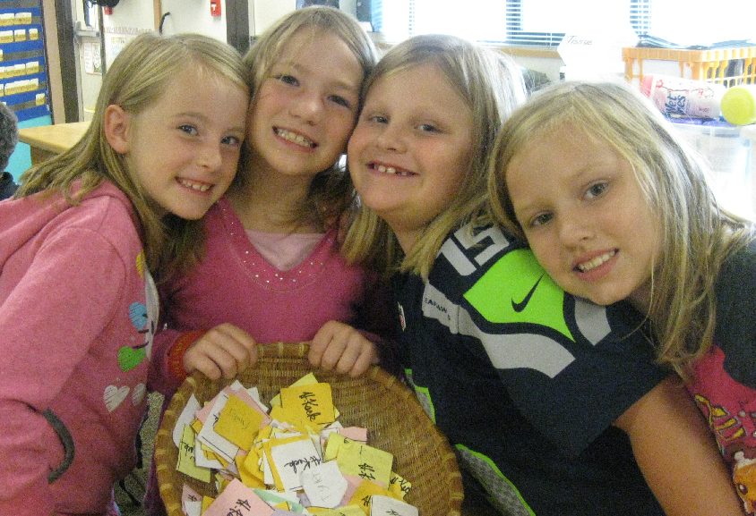
Learning – and earning good student behavior tickets – is fun in
Mr. Keck’s 2nd Grade classroom.

Bob Hodges

TITLE 1 IS IMPORTANT @ GARFIELD

Title 1 is the largest federal aid program for our nation’s schools. The intent of Title 1 is to improve the performance of all our students. Each state receives a basic program grant. The state then sends allotments to school districts based on a poverty index from the latest census. Garfield is a school-wide Title 1 School. Its free/reduced lunch count is approximately 65%. Each eligible student generates funding for this program. These funds allows us to provide extra help to students in reading and/or math.

What are Title 1 funds used for at Garfield?
- Salaries for our Title 1 teachers and para-educators
- Supplementary books and software
- Additional teaching and learning tools

The No Child Left Behind Act (NCLB)
This law applies to schools that receive Title 1 funding. Key elements of the law include:
- Highly Qualified. Teachers and para-educators must be highly qualified based on set criteria. All of our staff meets this rigorous standard.
- Student Accountability. Each 3rd-5th grade student must be tested on the state test called the MSP in reading and math. Students who do not meet the standard on these tests are given extra support. You can find out more information about how we did on the state assessments by going to the OSPI website: State Report Cards – Olympia School District – Garfield Elementary – AMO. We are proud of our MSP scores and how we have closed the achievement gap.
- Annual Measurable Objective. Each school is given an “Annual Performance Report Card” which tells how successful a school has been in reaching all groups of students. AMOs are unique yearly targets in reading and mathematics for each subgroup, school and district, as described in Washington’s Elementary and Secondary Education Act (ESEA) Flexibility Request. AMOs replace the state uniform bar used under Adequate Yearly Progress (AYP) as prescribed in the Elementary Secondary Education Act. Garfield not only made AMO this year, but exceeds many other schools with like-student populations for the last three years. In fact, Garfield was one of very few schools in the state to be honored as a Title 1 school.

Parent Involvement Plan
Garfield has an annual Parent Involvement Plan which outlines activities for the coming year. It is on the website and a few copies are available in the office. Additionally, we are looking for parents to serve on the district’s Title 1 Parent Advisory Committee. This group meets 3-4 times a year to help the district review and evaluate the entire district’s Title 1 program.

Pages from Brown Bear, Brown Bear books
created by Mrs. Mock’s Kindergarteners

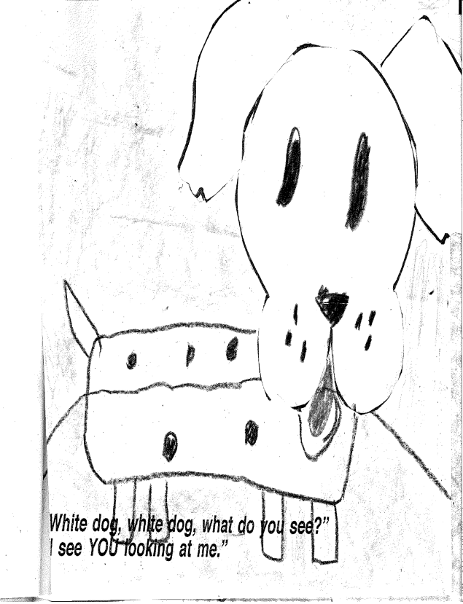

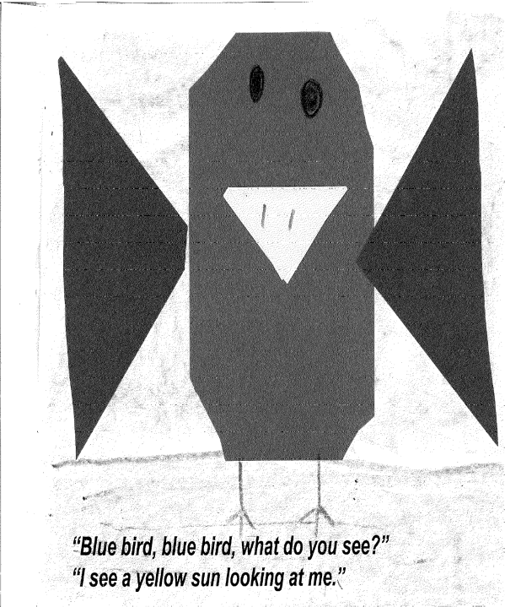

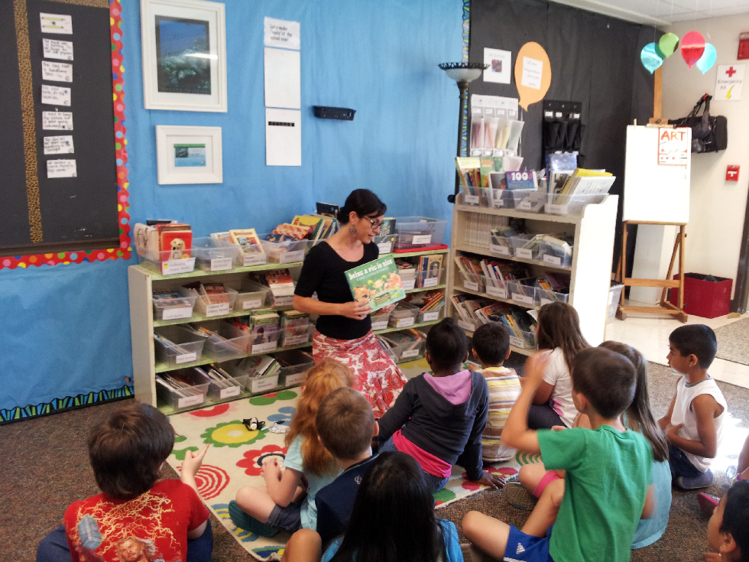
Mrs. Waite’s class has their own library…
and part-time librarian!

Mrs.Waite’s class has their own library library ...and part-time librarian

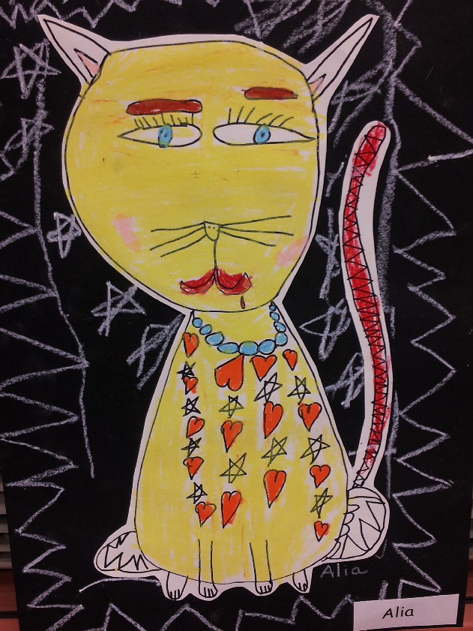
Cat Says…Fiddle-i-fee!
created by Ms. Yusko’s First Graders

Quality Student Writing

Cupcakes
by Avery A.-S. (5th - Koster)

Hold fast to cupcakes
For if cupcakes decay
The world will be unhappy
And wither away
Hold fast to cupcakes
For if cupcakes go
Life as we know it
Will be quite slow

Hamburgers
By Ty N. (5th - Koster)

Hold fast to hamburgers
For if hamburgers get burnt
Life is a fiery underworld
That burns hot.
Hold fast to hamburgers
For when hamburgers get messed up
Life is a tree that
can never move.

Friendly Letter
By Teferi G. (3rd - Duncan)

Dear Jasmine,
How are you doing?
I just have to say your hair is so curly; I love it!
Your eyes sparkle like diamonds; they are pretty.
Sincerely,
Teferi

My Cat
By Pamela B. (5th - Koster)

Tricky
Nikki
Picky too
Good kitty
Bad kitty
Cute kitty Wahoo!
Sweet kitty
Mean kitty
My kitty
Yes I’m talking to you
Little tummy
Big tummy
Thumping down the steps
Pork chops
Cream cheese
Beef jerky
She loves it all
She eats it too
My weird kitty is just like YOU!

Halloween Slime Soup
By Gianna G. (3rd - Duncan)

3 Hershey bars
4 chocolate eyeballs
2 Reese’s cups
6 candy strings
1 licorice
Juice
Sugar

Take a big bowl. Melt three Hershey bars. Mix 4 chocolate eyeballs. Melt 2 Reese’s cups. Cut bits of candy string. Add and cut a long red piece of licorice. Add juice and stir it. Then sprinkle sugar all over it. Now you have Halloween Slime Soup!!

